Name : Saswata Kumar Nayak Mail id : 22052504@kiit.ac.in
Superset id : 6363187 University Roll : 22052504
Week - 06

- Creating First react app
- Define SPA and its benefits
- Define React and identify its working
- Identify the differences between SPA and MPA
- Explain Pros & Cons of Single-Page Application
- Explain about React
- Define virtual DOM
- Explain Features of React

1. SPA (Single Page Application)
Loads one HTML page and updates content dynamically.
Benefits: Fast, smooth user experience, reduced server load.
2. React
A JavaScript library for building user interfaces.
Component-based, fast updates using virtual DOM.
3. SPA vs MPA
SPA MPA
Loads once Loads new page each time
Fast Slower
Uses JS routing Server routing
SEO is harder SEO is easier
4. SPA Pros & Cons
Pros: Fast, app-like feel, efficient.
Cons: SEO issues, initial load can be heavy.
5. React Overview
Builds UIs using reusable components.
Uses JSX and unidirectional data flow.
6. Virtual DOM
A lightweight copy of the real DOM.
React updates only the changed parts → faster performance.
7. Features of React
JSX syntax
Virtual DOM
Component-based
One-way data flow
Fast rendering
Strong community support
Output:-
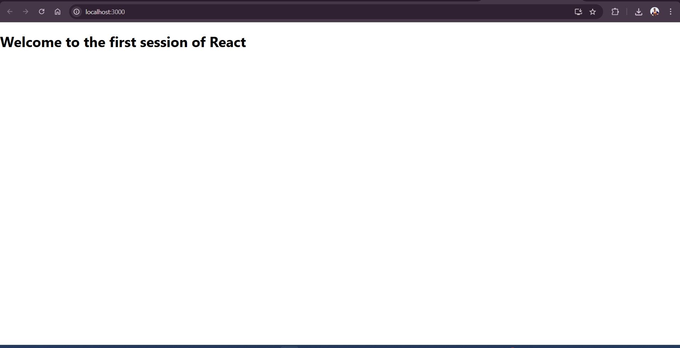
- Creating a react app for Student Management Portal -

Objectives

- Explain React components
- Identify the differences between components and JavaScript functions
- Identify the types of components
- Explain class component
- Explain function component
- Define component constructor
- Define render() function

1. React Components
Building blocks of a React UI.
Reusable pieces that return JSX (HTML + JS).

2. Components vs JavaScript Functions
React Component JavaScript Function
Returns JSX Returns values/data
Part of UI General logic
Has lifecycle No lifecycle

3. Types of Components
Class Component (older style)
Function Component (modern and preferred)

4. Class Component
Uses class syntax.
Has lifecycle methods and state.

class MyComponent extends React.Component {
render() {
return <h1>Hello</h1>;
}
}
5. Function Component
Simple function that returns JSX.
Uses Hooks for state and lifecycle.

function MyComponent() {
return <h1>Hello</h1>;
}
6. Component Constructor
Special method in class components.
Initializes state and binds methods.

constructor(props) {
super(props);
this.state = { count: 0 };
}
7. render() Function
Required in class components.
Returns JSX to display the UI.

render() {
return <div>UI goes here</div>;
}

Output :
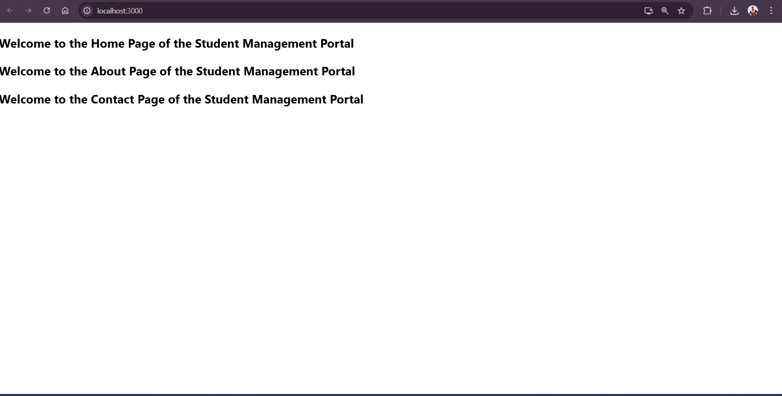

- Creating a react app for Student Management Portal - Calculate score

Objectives

- Explain React components
- Identify the differences between components and JavaScript functions
- Identify the types of components
- Explain class component
- Explain function component
- Define component constructor
- Define render() function
1. React Components
Core building blocks of React UI.
Return JSX to define how UI looks.

2. Components vs JavaScript Functions
React Components JavaScript Functions
Return JSX/UI Return data or logic
Can hold state Stateless
Have lifecycle methods No lifecycle

3. Types of Components
Class Components
Function Components

4. Class Component
Uses class syntax.
Supports state and lifecycle methods.

class MyComp extends React.Component {
render() {
return <h1>Hello</h1>;
}
}
5. Function Component
Uses simple function syntax.
Cleaner and supports hooks for state and effects.

function MyComp() {
return <h1>Hello</h1>;
}
6. Component Constructor
Used in class components.
Initializes state and binds methods.

constructor(props) {
super(props);
this.state = { count: 0 };
}
7. render() Function
Required in class components.
Returns JSX to be shown on the screen.

render() {
return <div>Hello World</div>;
}
Output :
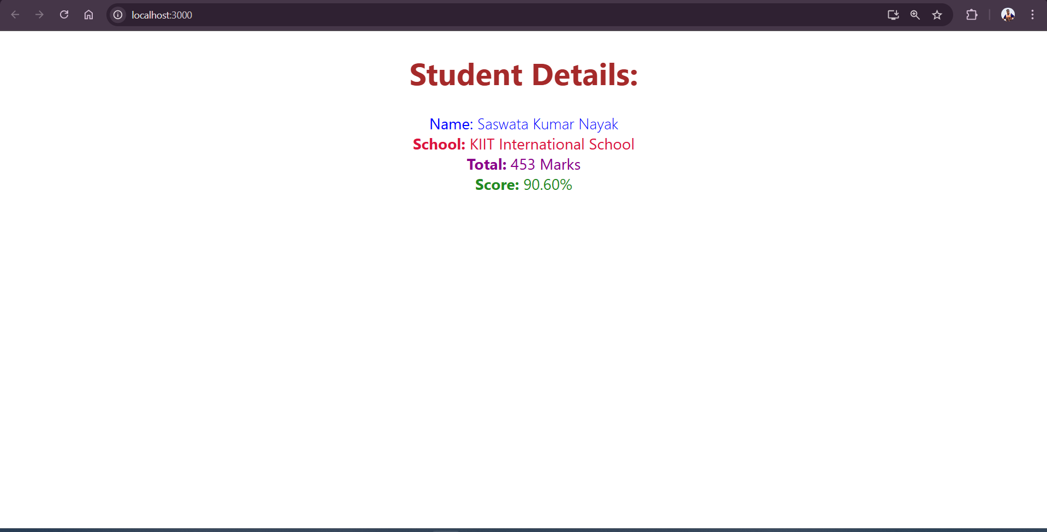
- Blogapp

Objectives
- Explain the need and Benefits of component life cycle
- Identify various life cycle hook methods
- List the sequence of steps in rendering a component
1. Need & Benefits of Component Lifecycle
Why it's needed:
To manage what happens when a component is created, updated, or destroyed.

Benefits:
Control over rendering.
Efficient resource management (like timers, API calls).
Helps in debugging and optimization.
Smooth integration with external libraries.

2. Lifecycle Hook Methods (in Class Components)
Phase Method Purpose
Mounting constructor() Initialize state
componentDidMount() Called after component is added
Updating shouldComponentUpdate() Decide if re-render is needed
componentDidUpdate() Runs after update
Unmounting componentWillUnmount() Cleanup before removal

In Function Components, lifecycle is managed using Hooks like:

useEffect() → replaces componentDidMount, componentDidUpdate, and componentWillUnmount.

3. Sequence of Steps in Rendering a Component (Class)
Mounting phase:
constructor()
render()
componentDidMount()
Updating phase:
shouldComponentUpdate()
reder()
componentDidUpdate()
Unmounting phase:
componentWillUnmount()

Output :
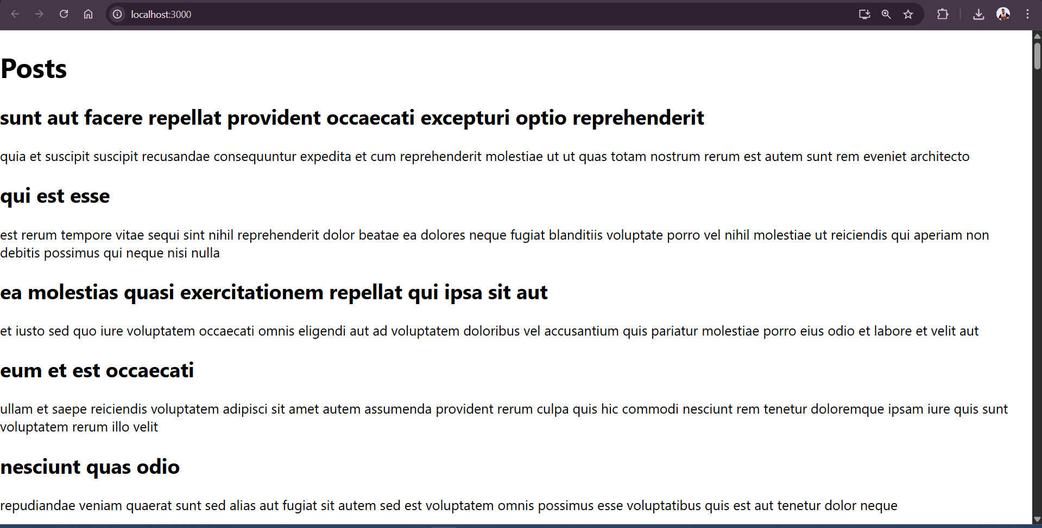
- Cohort Tracker

Objectives
- Understanding the need for styling react component
- Working with CSS Module and inline styles

1. Need for Styling React Components
Why style React components?

To make the UI visually appealing and user-friendly.
To maintain consistent design across components.
To reflect dynamic states (hover, active, etc.).

Benefits:
Better user experience
Branding and visual identity
Improved readability and structure

2. Working with CSS Modules
CSS Modules provide scoped styles to components (avoids class name conflicts).
File must end with .module.css.
Example:
/* styles.module.css */
.title {
color: green;
}
import styles from './styles.module.css';
function MyComponent() {
return <h1 className={styles.title}>Hello</h1>;
}
3. Working with Inline Styles
Defined as JavaScript objects.
Style names use camelCase instead of kebab-case.
Example:
const headingStyle = {
color: 'blue',
fontSize: '24px'
};
function MyComponent() {
return <h1 style={headingStyle}>Welcome</h1>;
}
Output :
